Chapter 18, Problem 50.

Determine v_{o}(t) in the transformer circuit of Fig. 18.52.

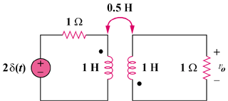

Figure 18.52
For Prob. 18.50.

